**ONLINE EVENT MANAGEMENT AND PLANNER**

**Assumptions –**

1. All the services obtained through this software are not dedicated to any particular company or organisation. This software acts as a mediator between the customers and the vendors.
2. All the actors have efficient and sufficient communication among themselves.
3. The vendors will make themselves available based on Customers’ request.
4. A vendor offering more than one type of service(among hall, catering, decorating and photography) must provide each service independently.
5. All payments must be done online.
6. The Customer must make the payment as billed by the Event Manager.
7. All the venders will be paid by the Manager. The Customer shall not intervene with the payments of the vendors.
8. To book a customized event, the Customer must submit a request with the necessary details that are to be evaluated. The approval for the said event should be awaited from thereon.
9. Details submitted by a Customer while booking an event must be unambiguous.
10. The Planner assigned by the Manager will be provided with all the details necessary to organize an event.
11. The profiles of the vendors in respective catalogues are to be maintained by the vendors themselves. A Customer can access these catalogues without registration.
12. The database contains all the event details with corresponding customer details, vendor accounts, planner profiles, service catalogues and financial documents (restricted access).

**Use – Case Diagram –**

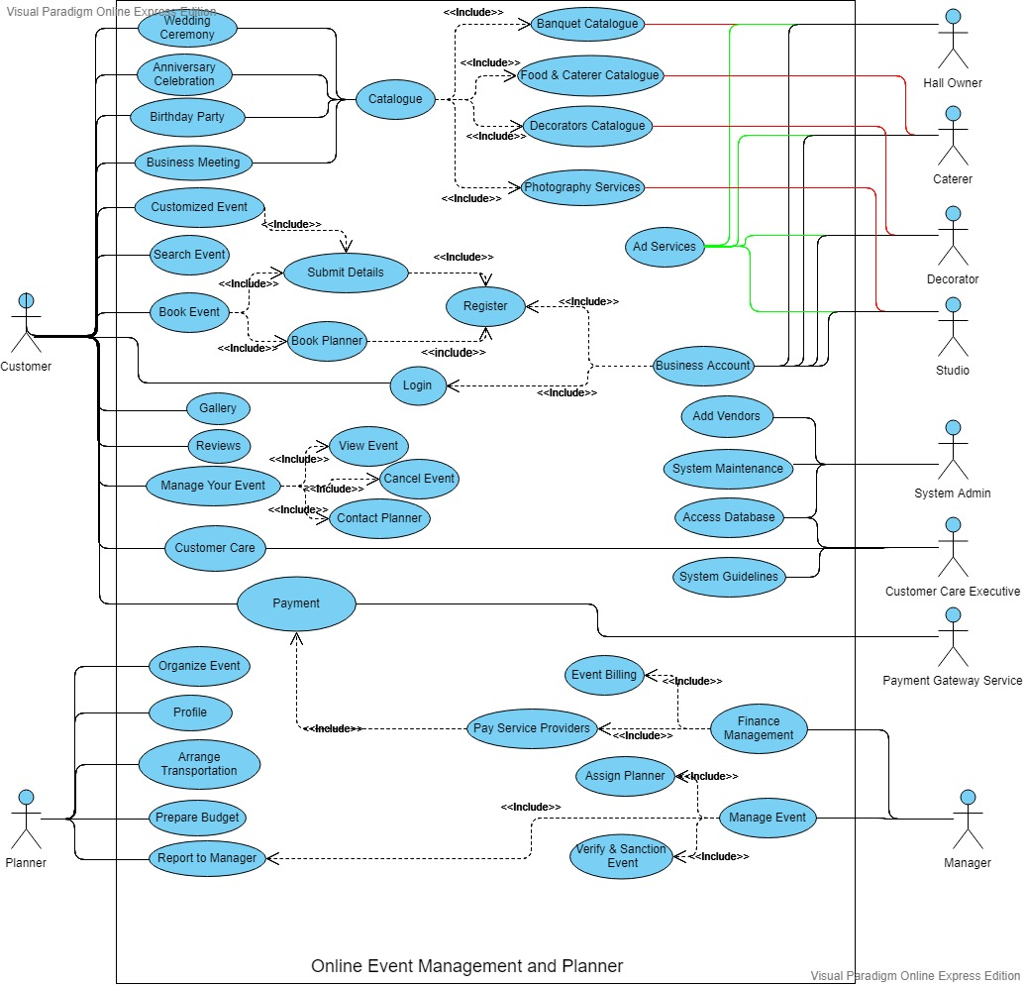

(This use-case diagram is also provided in a separate .pdf file)

**Description of the Use Cases –**

1. **Register**: Creates an account for a new Customer trying to book an event or a service provider willing to associate with the platform.
2. **Login**: To log into an existing account(Customer account/Business account).
3. **Wedding Ceremony/Anniversary Celebration/Birthday Party/Business Meeting**: Details of the specific events organized by the platform that includes an overview of the services offered, catalogues of vendors (banquets, caterers, decorators etc.), dedicated gallery, customer reviews.
4. **Customized Event:** Prompts the Customer to register(if not done already) and submit a request with details of the desired event(type of the event, brief description, date, services required).
5. **Book Event:** Prompts the Customer to register(if not done already), submit details(as discussed later) and also provides an option to book an Event Planner(as discussed later).
6. **Submit Details:** The Customer submits personal details, viz., customer name, customer address, valid identity proof(Aadhaar or PAN), contact no., email address and details about the specific event, viz., date of the event, services required, no. of guests, timing preference.
7. **Book Planner:** The Customer can opt for an Event Planner through this module.
8. **Search Event:** A Customer can browse through events previously managed and/or planned by the platform.
9. **Manage Your Event:** This module provides the Customer with functions like viewing the event, cancelling the event, progress made, contact the Planner etc.
10. **View Event:** A registered Customer can see the details of the event booked by him/her.
11. **Cancel Event:** A Customer can cancel an event that has been already booked.
12. **Contact Planner:** A Customer can communicate with the assigned planner.
13. **Gallery:** Albums maintained by the platform with images of events previously organized.
14. **Reviews:** Reviews and ratings of registered Customers on the services provided and their experience with the platform.
15. **Customer Care:** A Customer can contact with the Customer Care unit of the platform for inquiry.
16. **Catalogue:** This module gives the Customers a list of vendors for each type of services available on the platform, viz., banquet halls, catering services, decorators, photography services.
17. **Banquet Catalogue/ Food & Caterer Catalogue/ Decorators Catalogue/ Photography Services:** Each type of catalogue consists of a list of vendors associated with this platform. Each vendor has a profile in the catalogue that includes the services offered by them, plans offered and corresponding rate, gallery, customer reviews, address of their office, contact no. etc. The catalogues are maintained by the vendors themselves and can be viewed by any Customer.
18. **Ad Services:** This module allows the vendors to advertise their company or organisation on the platform, complying with the platform’s advertisement policies.
19. **Organize Event:** The Planner can organize the event as per the details submitted by the Customer.
20. **Profile:** Profile maintained by a Planner; includes the planner’s personal details, contact no., email address, experience, personal gallery, customer reviews etc.
21. **Arrange Transportation:** The Planner can arrange transportation services for the Customer.
22. **Prepare Budget:** The Planner can organize the event as per the budget set after discussing it with the Customer.
23. **Report to Manager:** The Planner has to report about the event being organized to the Manager.
24. **Manage Event:** The Manager verifies the event request submitted by the Customer and assigns a Planner if requested.
25. **Verify & Sanction Event:** The Manager assesses an event request submitted by the Customer and sanctions it if all the requests are valid.
26. **Assign Planner:** The Manager can assign a Planner if the Customer has booked one to organize the event.
27. **Finance Management:** The Manager handles the finances, including event billing and the payment of vendors and planners.
28. **Event Billing:** The Manager bills the Customer as per the services provided.
29. **Pay Service Providers:** The Manager pays the vendors who provided the services to a specific event and the Planner organizing the event.
30. **Payment:** Through this module the Customer can pay the bill for the event online and the Manager can pay the vendors and the Planners for their service. The secure gateway for payment is provided by a Payment Gateway Service.
31. **System Guidelines:** The Customer Care Executive can cater to customer queries regarding the rules and regulations and functionality as listed in the system guidelines.
32. **Access Database:** Customer Care Executive can access the database to answer to any query of the customers about the events being organized. The System Admin can also access the database to maintain and update the system.
33. **System Maintenance:** The System Admin maintains the system by updating the software, maintaining the database, maintaining transparency between various actors, updating rules and regulations, supervising security etc.
34. **Add Vendors:** The System Admin can add a vendor if the company wants to register itself on this platform as a service provider.